The Web Services on Mobile Shopping Automation

Chengchih Yang¹, Chengmin Lin², Shihsung Chen³
¹Department of Information Engineering
²Department of Computer and Communication Engineering
³Department of Multimedia Design
Nan-Kai Institute of Technology, Nan-Tou, Taiwan, China
{czyang, lcm, and sostc}@nkc.edu.tw

Abstract
This paper presents the Web services applying on a shopping automation across the Internet from portable mobile devices accessed by users. First of all, a shopping automation is considered as hardware system such as embedded device products. They are binding with web in some protocol. Another hand, the portable mobile devices also connected with web in WAP protocol. We model them in Web Services Description Language (WSDL) to represent such environment system. An example is described in this study that includes a General Packet Radio Service (GPRS) platform is used as the function of home gateways. In addition, an XML-based protocol is defined as the interface between web server and shopping automations.

Keywords: shopping automation, WAP, WSDL, GPRS, XML-based protocol

1. Introduction

Web services are more important with increasing the number of portable mobile devices, such as mobile phones, Personal Digital Assistant (PDAs). A typical Web services architecture consists of three entities, including service providers, service requesters, and service brokers [9]. Service providers create Web services for service requesters. These Web services are registered in service brokers and the brokers handle the requesting from service requesters and find published Web services of service providers. Hence, efficient access to Web services became an important issue. Ouzzani and Bouguettaya provide a query optimization model based on aggregation the quality of Web service parameters of different Web services [8]. In addition, Web services consist of three important protocols. First of all, Simple Object Access Protocol (SOAP) provides a simple and lightweight protocol for communicating between Web services and client applications. Next, Web Services Description Language (WSDL) is an Extensible Markup Language (XML) based language to be used for describing Web services. Furthermore, Thomas et. al use Petri Nets to model the WSDL [13]. Finally, the Universal Description Discovery and Integration (UDDI) is used to let Web services register their services for services requesters. In order to test and evaluate Web services, Tsai et. al provide an XML-based Framework that consists of test master and test engine [12]. The former allows testers to specify test scenarios and cases converted from WSDL specifications. After the Embedded Internet System (EIS) was proposed in 1998 [7], academic researchers in this field are increasing in number. For example, Szymanski [11], designed web that applied the EIS ideas to enable control webs to perform online monitoring. The Open Services Gateway Initiative (OSGi) [5], whose mission is to generate open specifications for delivering of various services over wide area networks to local networks and devices was founded in March 1999. The three core aspects of the OSGi mission are servers, various networks, and devices. In 2000, Topalis et al. implemented a home gateway to support automated home networks and home Internet connectivity [14]. In 2001, Saif et al. proposed a self-configuring software architecture for home area networks, which provides an extensible markup language (XML) based registry and a hypertext transmission protocol (HTTP) based event service [10]. In 2001, Filman applied an embedded computer to design a home gateway, because embedded computers had progressed from being simple machines to being “thinking” and sensing” machines [3]. Furthermore, Chen et. al in 2002 provide an XML-based graphical monitoring protocol for distributed systems [2]. In 2003, Kapsalis et. Al [6], used the technologies Object Link for Process Control (OPC) enable Internet access, and proposed a gateway to integrate various services. Although a large number of studies have been made on both Web service and home automations or shopping automations, little is know about integration of both. The first aim of this study is to develop a web-based monitoring system for providing Web services. The remainder of this article is organized as follows. Section 2 presents the proposed system architecture. Section 3 introduces this Web representation in WSDL and a simple protocol is defined as the interface between automation server and shopping automations. A mobile shopping automation example is illustrated in Section 4. Finally, Section 5 draws conclusions.

2. System Architecture

A three-tier application has front-end clients (e.g., browsers), middle-tier application servers (e.g., web servers), and back-end databases. It is one where the logical decomposition of the application is reflected both at the software and hardware level. Similarly, a mobile shopping automation system, including portable mobile devices, an application server, a database, an automation server, and a shopping automation network, is now constructed and show as Fig.1. The mobile device, the application server, and the database server can be regarded as a data process path, another way, the database server, the automation server and the shopping automations can be regarded as being a signal process path. They have a common database for data process path and signal process path. Although such an integrated model does not yet have a common standard for mobile monitoring, the definitions of among layers are useful to clarify rules and developments of the interface protocol. The server described above is used to perform the functions of an application server and automation server.
mobile
device
application server
database server
automation server
data process path
signal process path
Fig. 1. A mobile shopping automation architecture
shopping automation

3. Web Representation

Web representation is the main goal of this work. We’ll analysis those operations and protocol parameters in mobile shopping automation. For Applying WSDL, a WSDL flow model is used to model our system to descript our Web services. Finally, an automation network protocol in our system is described herein.

3.1 Operations and protocol parameters

Three operations are provided from application server to mobile user, including inquire, control, and push. A user can call on a web site to retrieve the sensor status Ts in the database. This procedure is called the inquire operation and is denoted as O^{q}. For the database, O^{q} is a read-only operation and so is a concurrent process. Next, a user can change the sensor status, and use a control operation to finish it. This control operation is denoted as O^{c}. It is not a concurrent process. This operation must cooperate with a mutual exclusion table to ensure consistency among data. Although database operations provide a transaction mechanism, an inconsistent state may occur. For instance, two users, A and B, simultaneously change the status of a single sensor. The successive operations are O^{q}_{a}O^{q}_{b}O^{c}_{a}O^{c}_{b} and an inconsistency arises. An automation server is built to prevent the above inconsistency. However, the server can process concurrent problems. The data process path can simply prevent inconsistency because the server provides a mutual exclusion mechanism. The last operation associated with the data process path is a push operation. For a mobile system, two models can be applied, pull and push. For push operation, the application server actively sends information to a user’s mobile device. SMS or MMS technology is employed to implement the push mode. Such an operation is denoted as O^{p}. Two operations are provided from automation server including in and out. The automation server extracts a control command from table T^{c} of the database and then sends the command to the sensor. The procedure to be used is denoted as Oº. Moreover, the server periodically reads the sensor status and then stores the status into the status table T^{s} and a message table T^{m}. This procedure is called in and is denoted as O^{i}. Then we draw them into the system block diagrams and show in Fig.2.

O^{q},O^{c}
O^{p}
inquire
control
message
Application server
Automation server
O^{i} Oº
in
out
T^{s}
T^{c}
T^{m}

Fig.2. operations on mobile environment

Furthermore, we define a mobile control web operation set O^{mcw}, includes five primary functions. O^{mcw} = {O^{q} , O^{c}, O^{p} Oº , O^{i}}. For the inquire operation O^{q} is used to represent an object embedded some parameters includes name, value, and protocol fields. The name filed is the name of the object. It consists of sixty-four characters and is unique to represent a primary key for this object. The value field is also string type because it can represent a value of float and integer. In addition, using string also represent a binary status into {on, off}. Protocol field parameter P^{h} is used to carry application server communication with client. For operations Oº , O^{i} , the parameter of protocol field P^{g} is used to carry automation server communication with shopping automations. We also define a protocol set P^{mcw} of a mobile control web includes two protocol parameters P^{h}, P^{g}.

3.2 WSDL flow model

WSDL is an XML-based document includes specific elements: types, message, port-type, binding and Service. It is used to describe what a web service can do, where it resides, and how to invoke it. In this study, we map the mobile shopping automation environment to WSDL as shown in Fig. 3. In this figure, there are two ports, port-c and port-s. The former uses WAP protocols to bind between a mobile client and an application and the latter is used to bind a sensor network and an automation server using sensor protocols. The protocol is defined in next subsection. In spite of port-c or port-s are used in GPRS wireless channels. When a request is send to the application server. Herein, the application is to play as a service broker. Hence, the application can find a suitable automation server from its Database registered by automation servers. When a application server is selected, it sends a query command to a specify sensor device in a sensor network through a GPRS channel. In our system, a sink node introduced by Akyildiz et. al [1] can receive the command and process this command to read the status of the specify sensor device. Next, the information of the specify sensor device backs to the automation sever by the sink node. Finally, the automation server provides this service, a required sensor status, to the mobile client that proposes this request.
Mobile Client
Application & Automation server
shopping automation

port-c
port-s
Fig.3. A mobile home automation for WSDL flow model
WAP Binding
Sensor Binding

Fig.4. The DTD of SN protocol

3.3 Sensor Network Protocols

In this section, we describe sensor network (SN) protocols in our system. The Document Type Definition (DTD) of the SN protocol is shown in Fig.4. There are two types of command elements: Digital Data In (DI), and Digital Data Out (DO) in this figure. Each command element has a device attribute. If a command is sent from a GPRS control platform to an appliance server, the device attribute is used to specify as the identification (ID) of the target device. If the command is sent from the appliance server to the GPRS control platform, the device attribute is used to store the ID of the source device.
<?xml version="1.0" encoding="UTF-8"?>
<!ATTLIST DI
device ID #REQUIRED
value (On | Off | Query) #REQUIRED>
<!ELEMENT DO EMPTY>
<!ATTLIST DO
device ID #REQUIRED
value (On | Off) #REQUIRED>
<!ELEMENT DI EMPTY>
<!--root element-->
<!ELEMENT SN (DI | DO)+>

4. Examples

The information server is constructed using server operation systems such as Windos2000 Server or Windos2003 Server, and application software for web pages and databases. A remote appliance monitor is composed. It has a control platform MA8-6 that contains multi-type I/O interfaces, DIO, RS232 or RS485, linked to the web’s appliance server via GPRS protocols. This system can be used as a set of sensors to detect earthquakes, stealers, or fires. Appliance server access several numerous detector data and save to the public databases for information server sharing. The main effect of the application server is just to provide a html or asp.net webpage to supply an ideal interface between the web’s database and the user of a cellular phone. The user can enquire about, and control the appliances from his or her cellular phone through the WAP or HTTP protocol. Figure 5 shows a sensor network that consists of anti-fire, anti-earthquake and anti-stealing circuit-broad, and the GPRS control platform, MA8-6. Figure 6 shows the states of the appliances from database using an IE browser.

5. Conclusions

This study addresses an integration of web services apply on mobile shopping automations. We hypothesize that it can be treated as a both software and hardware architecture in order to model the relation between Web services and mobile shopping automation. The servers provide mobile Web services and automations controls. They are important roles in our system. The application server is a service broker, the automation server is a service provider, and a mobile client, mobile phone or PDA, is service request. The architecture of Web services for mobile shopping automation is represented. In addition, the GPRS mechanism and protocol of SMS can be used to achieve real-time monitoring functions for remote monitoring.

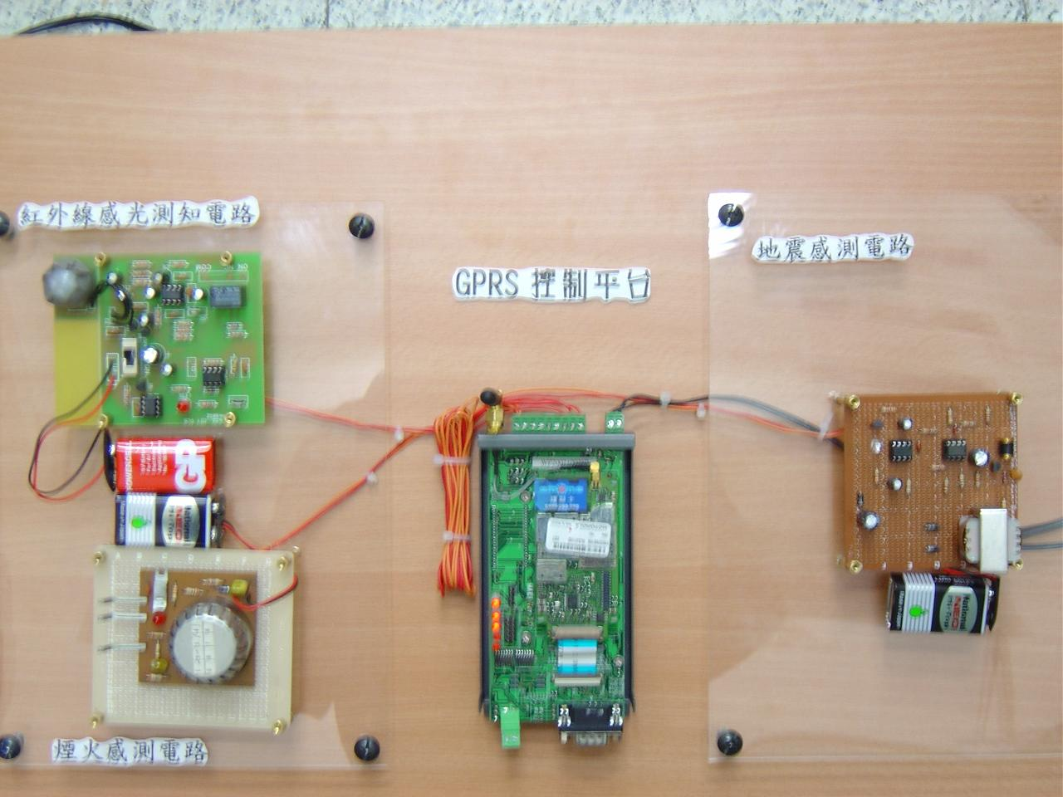  anti-earthquake circuit-broad  MA8-6 GPRS platform  anti-stealing  circuit-broad  Fig. 5. GPRS platform, MA8-6 and related circuit | Fig. 6. The status of appliances by IE browser from database  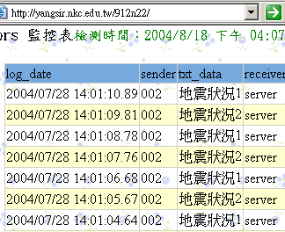

Acknowledgement

The authors would like to thank the National Science Council of Taiwan, China for financially supporting this research under Contract NSC-91-2213-E-252-008.

References

- I. F. Akyildiz, W. Su, Y. Sankarasubramaniam, and E. Cayirci, “Wireless Sensor Networks: a Survey,” Computer Networks, no. 38, pp. 393-422, 2002.
- S. S. Chen, C. M. Lin and S. S. Wu, “An XML-based Graphical Monitoring Protocol for a Distributed Graphical Monitoring System,” in the Proceedings of 2002 International Conference on Chinese Language Computing, 2002.
- R. E. Filman, “Embedded Internet Systems Come Home,” IEEE Internet Computing, vol. 5, no. 1, pp. 52-53, Jan./Feb. 2001.
- S. Frolund and R. Guerraoui, “e-Transactions: end-to-end reliability for three-tier architecture,” IEEE Transactions on Software Engineering, vol. 28, no. 4, pp. 378-395, 2002.
- L. Gong, “A Software Architecture for Open Service Gateways,” IEEE Internet Computing, vol. 5, no. 1, pp. 64-70, Jan./ Feb. 2001.
- V. Kapsalis, K. Charatsis, M. Georgoudakis, and G. Papadopoulos, “Architecture for Web-based Services Integration,” The 29th Annual Conference of the Industrial Electronics Society (IECON ’03), vol. 1, pp. 866-871, 2003.
- B. Lee, “Embedded Internet Systems,” IEEE Internet Computing, vol. 2, no. 3, pp. 24-29, 1998.
- M. Ouzzani and A. Bouguttaya, “Efficient Access to Web Services,” IEEE Internet Computing, vol. 8, no.2, pp. 33-34, Mar.-Apr. 2004.
- J. Roy and A. Ramanujan, “Understanding Web Services,” IT Professional, vol. 3, no. 6, pp. 69-73, Nov.-Dec. 2001.
- U. Saif, D. Gordon, and D. J. Greaves, “Internet Access to a Home Area Network,” IEEE Internet Computing, vol. 5, no.1, pp. 54-63, Jan./Feb. 2001.
- J. W. Szymanski, “Embedded Internet Technology in Process Control Devices,” the Proceedings of IEEE International Workshop on Factory Communication Systems, pp. 301-308, 2000.
- W. T. Tsai, R. Paul, W. Song, and Z. Cao, “Coyote: An XML-based Framework for Web Service Testing,” in the Proceedings of 7th IEEE International Symposium on High Assurance Systems Engineering, pp. 173-174, Oct. 2002.
- J. P Thomas, M. Thomas, and G. Ghinea, “Modeling of Web Services Flow,” in the Proceedings of IEEE International Conference on E-Commerce, pp. 391-398, June 2003.
- E. Topalis, G. Orphanos, S. Koubias, and G. Papadopoulos, “A Generic Network Management Architecture Targeted to Support Home Automation Networks and Home Internet Connectivity,” IEEE Transactions on Consumer Electronics, vol. 46, no. 1, pp. 44-51, Feb. 2000.

